|  |  |
| --- | --- |
|  |  |
| Visualization Report on Violence in African from 2019 - 2022 |  |
|  |  |
|  | Visualizing Data |
|  | Erifeoluwa JamgbadiC18387973 |

**Description of dataset and their origin**

I got the dataset from ACLED website. I used the data export tool to filter the specific dataset that I wanted. The dataset is about the different violence that took place in different parts of Africa from 2019 – 2022 [https://acleddata.com/data-export-tool/ ]. The original dataset has 31 columns in total and a total of 19579 data entry for each column. There are different details on the event that took place in each of the countries in Africa, such as the event date, year, who were involved, place of event etc.

**An explanation of what you discovered when you explored the data**

* The history behind violence in countries, is that the citizen ends up suffering the most.
* Some countries in west Africa are Mali, Nigeria, Niger, Guinea, Liberia, Senegal, Mauritania, Ghana, Ivory Coast, Sierra Leone, Togo and Cape Verde
* Between the four years (2019 -2022), 2020 was the worst for violence in west Africa (refer to bar chat). I agree with this because the endsars movement took place in 2020 in Nigeria.
* The dataset had a total of 19579 rows of data for each column and there were 31 columns.
* Most of the column types were character.
* The biggest event was violence against the citizens in west Africa and it is mainly caused by military personnel’s, police etc basically people in power.
* Nigeria has the highest occurrence of these events.

**The Big Idea of Visualization**

It is important to be aware of different things that are happening in the world, especially with social media, so we have information really easily. To spread awareness of the different types of troubles citizens face, especially at the hand of people in power in west Africa, more specifically Nigeria. “Use social Media and find out more”.

1. List the primary groups or individuals to whom you will be communicating.

* People from the west African countries
* Parents
* Friends

1. If you had to narrow that down to a single person, who would it be?

* People from west African countries.

1. What does your audience care about?

* History
* Africa

1. What action does your audience need to take?

* Being aware and just spreading awareness whenever they see information.

What is at stake?

People not being aware of the suffering that is going on in west Africa.

**The visualization and storytelling (include images of the chart)**

We are going to be focusing on africa today, more specifically west africa. I am from nigeria, which is located in west africa, so I wanted to spread more awareness through these visualisations of troubles citizens face at the hand of people in power.

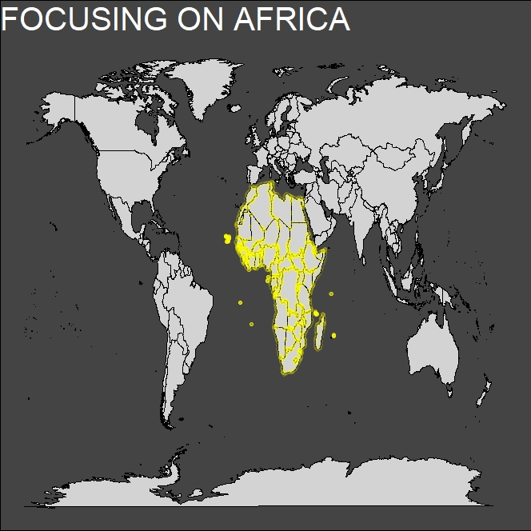

These are the countries that are in the west of Africa. Most people don’t know some of these countries, but when talking about the violence in a specific country, other close neighboring countries were included because some were going through the same things. So it was important to compare and contrast because if they were able to do something to solve a specific problem, then it could be used in another country as well.

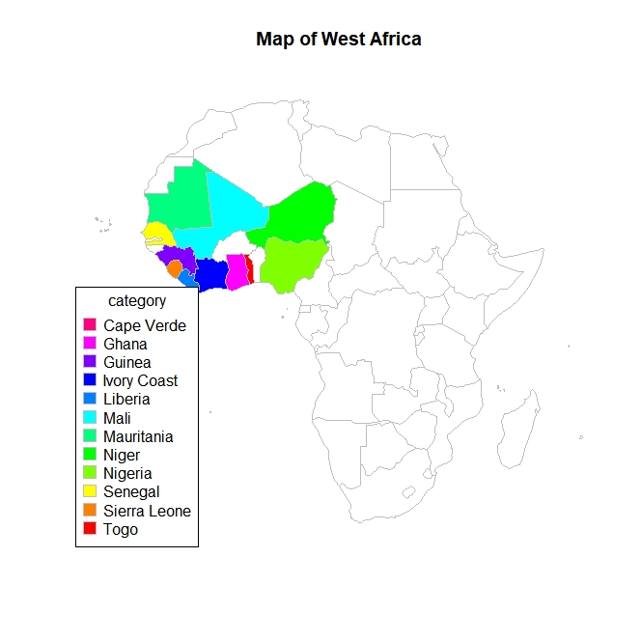

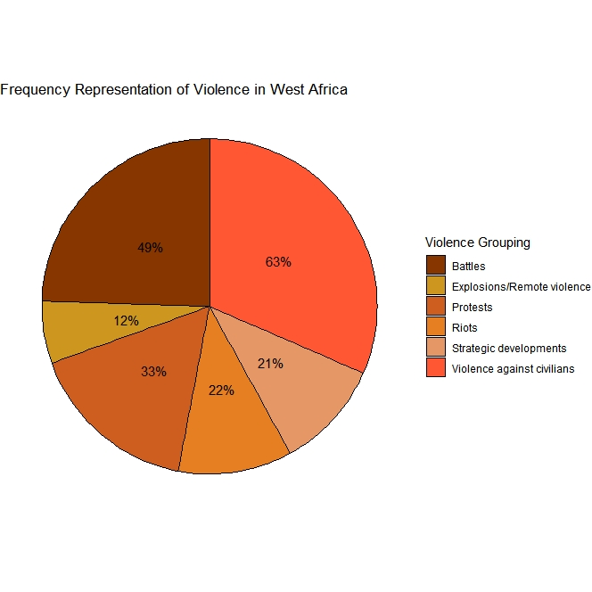

There are different types of violence that occurs in different parts of the world, so it is important to highlight these ones that were specific to the countries in west Africa. They are grouped under the following heading as shown in the pie chart above. Violence against citizen is the highest in west African countries and this is a problem as the citizens should not be suffering from such.

To break down these grouping more, the map below shows the breakdown of these events and the location of their occurrence.

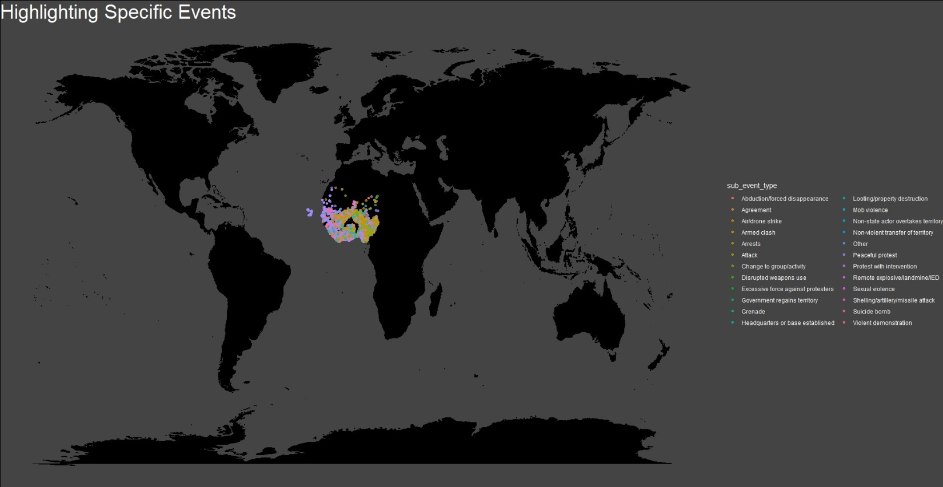

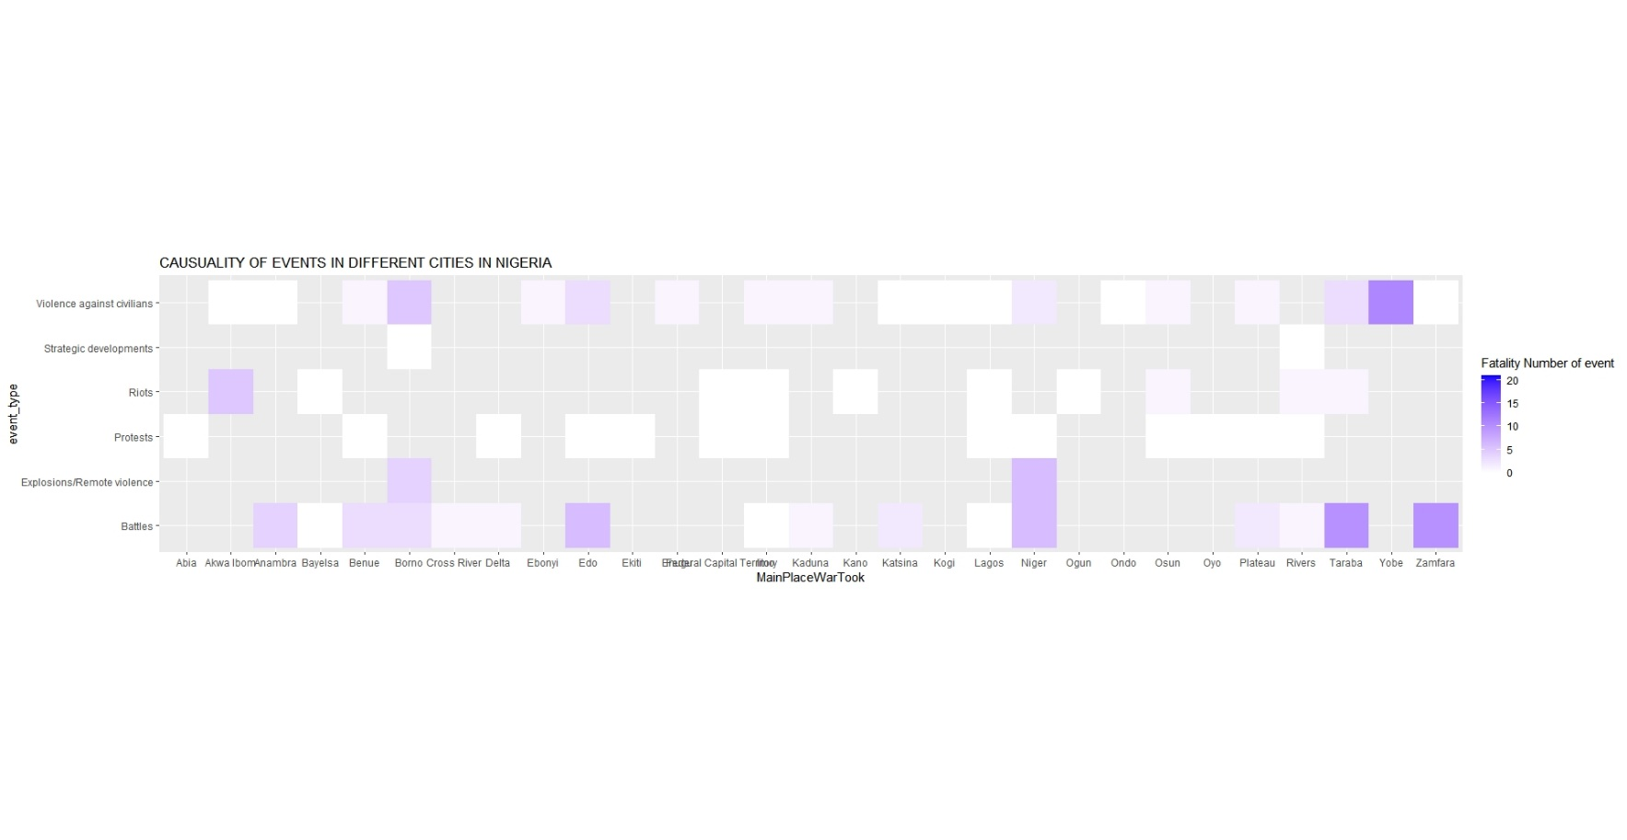

After looking the neighboring countries, we look more specifically at Nigeria and the fatalities in each of the cities.In 2022, Zamfara was hit the worst compared to the other cities in nigeria in terms of battles (the recent attacks that were done against the normal everyday people), with Taraba recording high numbers for violence against citizens

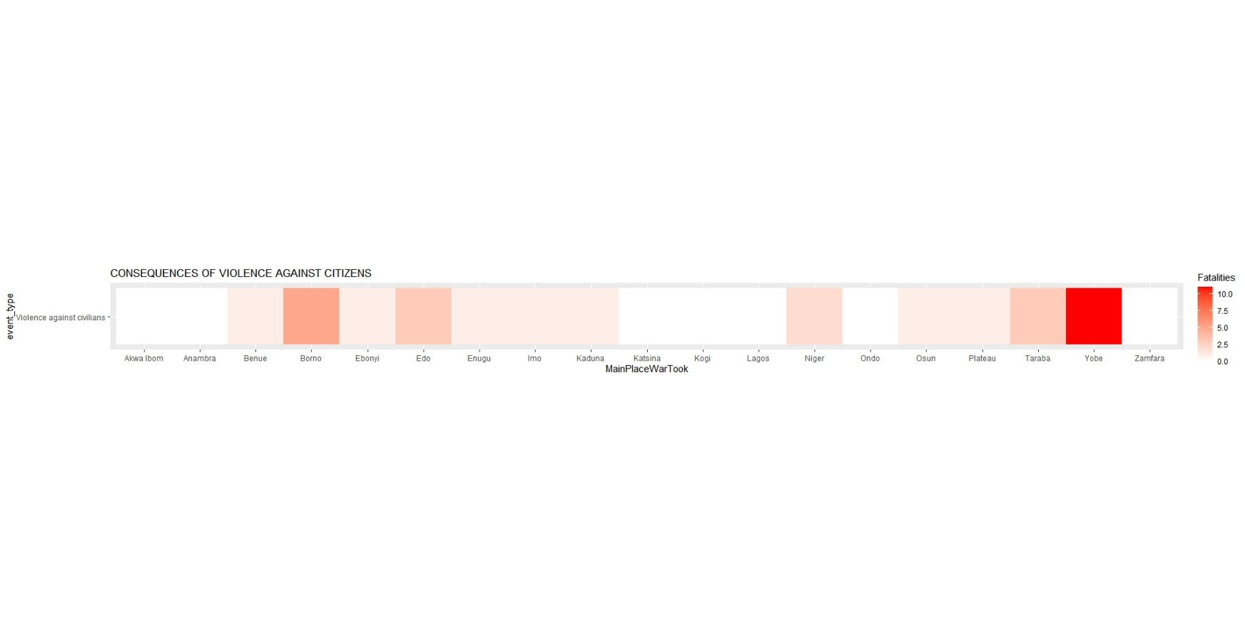

The citizen of Yobe recorded the highest for violence against its citizen. Mainly because of the religion tension. Nigeria has three main religion – Christianity, Islam and the once local to people (Indigenous religion), so it some parts there is religious divide and tension and this plays a part in power as well, especially in the case of how religions tension is handled, but at the end of the day, its mostly the citizens that have nothing to do with the “goal” that they are fighting for that suffer.

It’s important to focus on the rate of violence against the citizens and by especially look at who the perpetrators are.

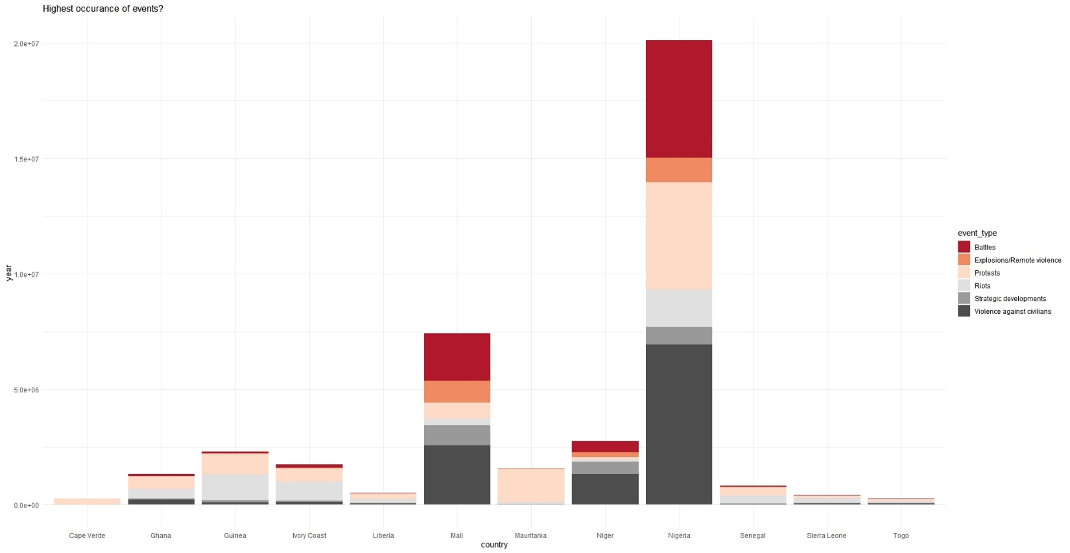

I though it was important to bring awareness to this issue and focus specifically on Nigeria not only because I am from there, but also because it has the highest rate of violence among the west African countries. I hope this visualization has helped to shed light on a different part of the world and bring awareness to somethings that are going on.